Thank you and Welcome to Victoria Point State School

What sets Victoria Point State School apart from other schools? It’s not our long and celebrated history, our tranquil grounds or our well-appointed classrooms, but rather our vibrant, supportive and diverse school community – our students, our staff and parents – that make the difference at Victoria Point.
The school’s experienced and dedicated staff deliver personalised quality academic programs and are committed to the development of the potential in every child.
Each and every day we think about our students, we care for them and about them and we have high expectations of them – and ourselves.

As educators we are constantly searching for new ideas and practices so that we may provide the best learning possible to all of our students.

I am proud to be the Principal of Victoria Point State School – a school where young people can be both successful and happy and where our students understand our motto:
‘ Always Our Best’
Come and enjoy our school with us. I look forward to welcoming you to our school family.

Yours faithfully

Bill Carey
Principal

VICTORIA POINT STATE SCHOOL
School Road, Victoria Point 4165
P O Box 3227, Victoria Point West 4165
Phone: ( 07 ) 3820 5666 Fax: ( 07 ) 3820 5600
COMMUNICATION
Forms of communication usually include parent workshops, parent-teacher interviews, children's written reports, informal chats and regular newsletters.
News: Our school newsletter is issued fortnightly on Thursdays. It contains important information with regard to school matters and is the major means of communication between the school and home, so each edition is consecutively numbered. Parents are asked to peruse each copy. A copy is loaded onto our school website and emailed to families.
Website: Our website is updated regularly with school information and policies. www.vicpointss.eq.edu.au
Information Updates
These are written on specific topics and will go home at different times throughout the year.

SMS Service. - SMS text messaging as a way of communicating important school information to our parents and caregivers. We ask that at least one parent continues to receive SMS messages as this is our major communication channel between school and home for special reminders and emergencies.
The school has introduced a service to communicate with parents through SMS. Please let the office know if you wish to be included in this service.

Please complete and return to the office to ensure your communication is received.

Childs Name _______________________________ Class ___________________________

Email Address for Newsletter ___________________________________________________

SMS Text Messaging
Parent/Caregiver Name: ____________________________
Student Name: __________________________________
Mobile no: ______________________________________
School Road
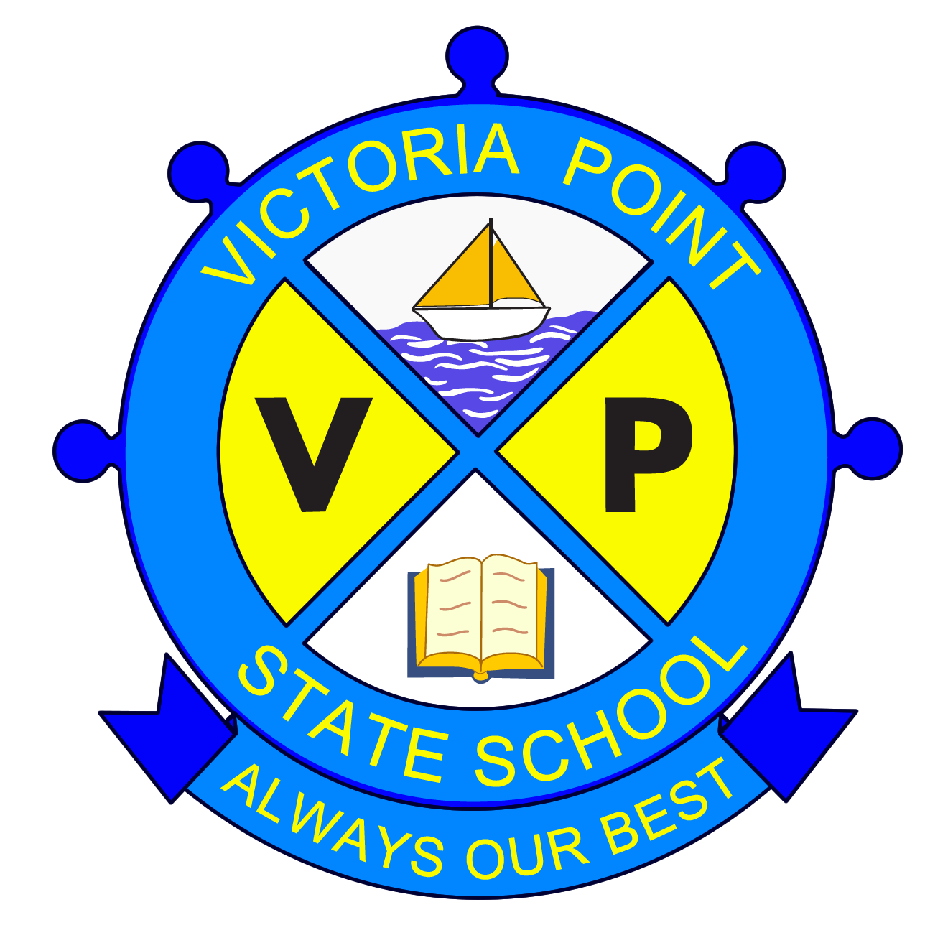
Victoria Point Qld 4165

Phone 3820 5666
Fax 3820 5600
Principal: Bill Carey
Acting Deputy Principal: Claire Milton

Dear Parent/Guardian
Students at Victoria Point State School may have access to the Internet. This ensures that students enjoy its educational benefit. At the same time, it is necessary to establish guidelines for the way the Internet is to be used.
The Internet will be made available to our students to facilitate educational research, to enable students to retrieve information and to communicate with other students both in Australia and around the world.
Although the Internet offers Victoria Point State School students many opportunities to benefit educationally, there are a number of ethical and legal issues that we must consider.
While every reasonable effort has been made to block access to sites containing inappropriate material, there is no guaranteed means of preventing student exposure to such sites, especially where a student deliberately seeks out this type of material. If a student unwittingly encounters material that is inappropriate, offensive, inaccurate or illegal, it is expected that they report this to their teacher.
Attached to this is an Internet Information Bulletin and an Acceptable Use Contract that should be gone through with your son/daughter, the contract signed by the student and counter signed by the parent/guardian.
In summary, the contract states that if the student uses the Internet or email for inappropriate purposes he/she will lose access i.e. “Abuse it and lose it”.

Bill Carey
Principal
Internet Information
What is the Internet?
The Internet is a worldwide network of individuals, groups, communities and organisations linked via computer.
Who can use the Internet?
Anyone who has a computer, modem and is linked to a service provider.
Features of the Internet
- Find information using a search engine
- Download computer programs and files
- Communicate with others via electronic mail or e-mail
- Interact as a group
- Interactive discussion
Why are educational institutions using the Internet?
Teachers and students are using the internet to locate information, send electronic mail, browse documents or images from various sites such as libraries, universities, industry and other organisations in Australia and overseas.
Educational Institutions use the Internet for:
- Electronic mail
- Accessing information
- Electronic publishing
- Communication e.g. through a Web Page
- Curriculum projects
- Inservice and training
- Technical support
What about the availability of unacceptable material on the Internet.
There has been much media attention to this aspect of the Internet. There is no absolute guaranteed means of preventing students’ exposure to this material. The school and Department of Education and the Arts have developed monitoring strategies and provide supervision of students using the Internet. Blocking software is utilized that prevent students from accessing many unacceptable sites.
What are the consequences of improper use?
The following consequences may apply for breaches of the Acceptable Use Contract.
- Withdrawal of entire access privileges
- Detentions / suspensions

STUDENT INTERNET ACCESS AGREEMENT
I understand that the Internet can connect me too much useful information stored on computers around the world.
While I have access to the Internet I will not:
- Attempt to retrieve, view or print any obscene, offensive, pornographic or illegal material
- Threaten, abuse or harass any other user
- Send offensive, racist or sexist messages
- Send anonymous or falsely addressed email
- Bring Victoria Point State School into disrepute in any way whatsoever
- Allow anyone else to use my account or give my password to anyone else
- Use another student’s account or tamper with another student’s account in any way
- Download or print information without permission
- Use chat channels without permission
- Attempt to change system settings in any way
- Attempt to bypass security
- Disclose my home address, telephone number, credit card or pin number over the internet
I also agree that I will:
- Use my account solely for educational purposes
- Observe all copyright laws including those relating to computer software
- Respect the rights and privacy of other users
- Report any obscene and offensive materials I encounter, quietly, to my teacher
- Report any security lapses that I may discover
- I understand that if the school decides I have broken these rules, appropriate action will be taken. This may include loss of my Internet access for some time, detentions and / or suspension.
_______________________________________ (Student’s name)
________________________________________ (Student’s signature) _________________ (Date)
Parent or guardian
I understand that the Internet can provide students with valuable learning experiences.
I also understand that it gives access to information on computers around the world; that the school cannot control what is on those computers; and that a very small part of that information can be illegal, dangerous or offensive.
I accept that, while teachers will always exercise their duty of care, protection against exposure to harmful information should depend finally upon responsible use by students.
I believe ___________________________ (Name of student) understands this responsibility, and I hereby give my permission for him/her to access the Internet under the school rules. I understand that students breaking these rules will be subject to appropriate action by the school. This may include loss of Internet access for some time, detentions and / or suspension.
____________________________ (Parent / guardian’s name)
___________________________ (Parent / guardian’s signature) ________________ (Date)
School Road
Victoria Point Qld 4165
Phone 3820 5666
Fax 3820 5600

Principal: Bill Carey
Acting Deputy Principal: Claire Milton
Enrolment Agreement
This enrolment agreement sets out the responsibilities of the students, parents or carers and the school staff about the education of students enrolled at Victoria Point State School.
Responsibility of students to:
- Attend school regularly, on time, ready to learn and take part in school activities;
- Act at all times with respect and show tolerance towards other students and staff;
- Work hard and comply with requests or directions from the teacher and principal;
- Abide by school rules, meet homework requirements and wear school’s uniform; and
- Respect the school environment.
Responsibility of parents to:
- Attend open evenings for parents;
- Let the school know if there are any problems that may affect my child’s ability to learn;
- Inform school of reason for any absence;
- Treat school staff with respect and tolerance;
- Support the authority and discipline of the school enabling my child to achieve maturity, self discipline and self control, and
- Abide by the school’s policy regarding access to school grounds before, during and after school hours.
Responsibility of school to:
- Develop each individual student’s talent as fully as possible;
- Inform parents and carers regularly about how their children are progressing;
- Inform students, parents and carers about what the teachers aim to teach the students each term;
- Teach effectively and to set the highest standards in work and behaviour;
- Take reasonable steps to ensure the safety, happiness and self-confidence of all students;
- Be open and welcoming at all reasonable times and offer opportunities for parents and carers to become involved in the school community;
- Clearly articulate the school’s expectations regarding the responsible behaviour plan for students and the school’s dress code policy;
- Contact parents and carers as soon as is possible if the school is concerned about the child’s school work, behaviour, attendance or punctuality;
- Deal with complaints in an open, fair and transparent manner;
- Consult parents on any major issues affecting students, and
- Treat students and parents with respect and tolerance.
I accept the rules and regulations of the Victoria Point State School as stated in the school policies that have been provided to me as follows
- Responsible Behaviour Plan for Students
- Student Dress Code
- Homework Policy
- School Charges and voluntary contributions
- Student usage of Internet, intranet and extranet
- Absences
- School Excursions/Camps
- Complaints management
- Parent Notice for Religious Instructions in School Hours
- Consent to use Copyright Material, Image, Recording of Name
- Appropriate use of Mobile Telephones and other Electronic Equipment by Students
- Medication
- Fitness, Sport and Recreation
- Smart Choices
I acknowledge that information about the school’s current programs and services has been explained to me.

_________________________ ______________________ _______________________________
Student Signature Parent / Carer Signature On behalf of Victoria Point State School
P & C !!!

I know what you’re thinking, but trust me volunteering can be fun and very rewarding. VPSS P & C is very active and are a very real part of this community. Your child starting school is a great opportunity to get out and meet new people.

Our fundraising efforts do not go unnoticed and becoming a member gives a unique insight into the workings of the school and the decisions that are made which affect your child’s education. It is also fantastic when we see our hard work turn into new teaching resources or beautification of our school, and of course the kids’ faces when they notice something new we have provided.

We alternate between day and night meetings, once a month and communication is made weekly through the newsletter.
So, spare a thought about how you might want to get involved. Any help you can give is appreciated and welcome.
Volunteers Needed

The Snack Shack is always in need of volunteers and I would like to invite you to help out. The Snack Shack operates 3 days per week – Wednesday, Thursday & Friday and my helpers usually assist one or two days per month. If you feel you cannot help for the whole 4 ½– 5 hours please offer just a couple of hours per month.

Snack Shack duty is not difficult or time consuming, your children will thoroughly enjoy seeing you at school and – believe it or not – it’s fun – just ask a Snack Shack helper. Without your help the Snack Shack cannot operate.

Please tick in the appropriate box below if you can help and return it to the school office or Snack Shack as soon as possible.
Thank you.
Louise Mead
Snack Shack Convenor

 | Wednesday | Thursday | Friday
1st of each month

2nd of each month

3rd of each month

4th of each month

5th of each month

NAME:

PHONE NO.:

CHILD’S NAME & CLASS:

